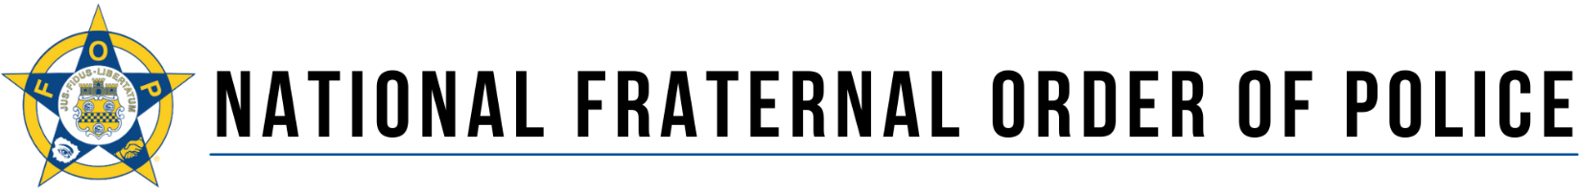

FOR IMMEDIATE RELEASE CONTACT: TIM RICHARDSON
23 February 2023 (202) 547-8189

Protect and Serve Act Introduced in House:
Bill Addressed the Increase in Targeted Attacks Against Police

Washington, DC – Patrick Yoes, National President of the Fraternal Order of Police,
applauded the reintroduction of H.R. 743, the “Protect and Serve Act.” The bipartisan bill was introduced by Representatives John H. Rutherford (R-FL) and Joshua S. Gottheimer (D-NJ) and four other original cosponsors: Representatives Elise M. Stefanik (R-NY), Jared F. Golden (D-ME), Peter A. Stauber (R-MN), and C.A. “Dutch” Ruppersberger (D-MD).

“This bill has been re-introduced in response to the surge of violence directed at law enforcement officers in the form of calculated and ambush-style attacks. The ‘Protect and Serve Act’ would impose Federal penalties on individuals who deliberately target law enforcement officers with violence,” Yoes said. “Just one month ago, Officer Gonzalo Carrasco, Jr. of the Selma Police Department in California, was on patrol and flagged down by a local citizen who was concerned about a suspicious person in her backyard. When Officer Carrasco exited his squad car, he was ambushed and shot several times. He was rushed to the hospital but later died there of his wounds.”

This legislation would impose, in limited circumstances, Federal penalties on individuals who deliberately target local, State or Federal law enforcement officers with violence. So far this year, 55 officers have been shot and seven officers have been killed by gunfire. There have been 19 ambush-style attacks, which has resulted in 16 officers having been shot, three of whom died.
“Our members are increasingly under fire by individuals motivated by nothing more than a desire to kill or injure a cop. Law enforcement officers, who serve their communities and put their lives on the line for fellow citizens, should not be hunted and targeted just because of the uniform that they wear,” Yoes said.
Ambush attacks and violence targeting law enforcement officers have been steadily increasing in recent years. A recent report from the Federal Bureau of Investigation (FBI) concluded: “While the overall number of officers who were feloniously killed was declining, the percentage of officers feloniously killed during surprise attacks was increasing.” A December 2017 study by the Office of Community Oriented Policing Services (COPS), which examined law enforcement officer fatalities from 2010-2016, found that 20% of ambushed officers were seated in their patrol cars and 56% of
officers killed in an ambush were not on a call or engaged in any enforcement activity. Many of these officers were simply eating, sitting on post, or were targeted and killed while at their home or on their way home.
“Law enforcement is a higher calling for those who take the oath to protect and serve. It is these men and women who run toward danger to protect the public when everyone else is running away,” stated Yoes. “No officer should be at risk of being targeted while simply sitting in their patrol car, standing post, or heading home at the end of a shift. When a member of the public calls for help, we answer that call. Now, we are asking for help now and urge all Members of the House to support this legislation.”
###
Founded in 1915, the Fraternal Order of Police is the largest law enforcement labor organization in the United States, with more than 364,000 members. With national offices in Nashville, Tennessee, and Washington, D.C., the FOP is committed to improving the working conditions of law enforcement officers and the safety of those served through education, legislation, information, community involvement, and employee representation. Please visit https://www.fop.net for more information.

